*<Adoption Center Database>*

Term Project Report

Version *<1.0>*

*<11/30/2023>*

TABLE OF CONTENTS

**1** **Project Description 3**

**2** **Team Members’ role 3**

**3** **ER Diagram / relational schema 3**

**4** **Assumption and Limitations OF the design 3**

**5** **cardinality relationships 3**

**6** **Data Dictionary 3**

**7** **Sample Data 3**

**8** **SQL Queries** Error! Bookmark not defined.

8.1 Table creation queries 3

8.2 Data Insertion Queries 3

8.3 Screenshot of DB tables and data instances 3

**9** **Own SQL queries 4**

# Project Description

This Adoption center database system shows the components and process of pet adoption. This database system manages adopter information, pet information, adoption transactions, employee details, and different adoption center information.

# Team Members’ role

**Logan**: Logan was responsible for creating and inserting data into the Pet data table. He also created three difficult queries while aiding in finishing the report.

**Celine**: Celine was responsible for creating and inserting data into the Employee and Adoption Center data table. She also created three difficult queries while aiding in finishing the report and combining all our separate files into complete Java files.

**Jacob**: Jacob was responsible for creating and inserting data into the Adoption Transaction data table. He also created three difficult queries while aiding in finishing the report and combining all our separate files into complete Java files.

**Ishaan**: Ishaan was responsible for creating and inserting data into the Adopter data table. He also created three difficult queries while aiding in finishing the project report.

# ER Diagram / relational schema

**Before:**

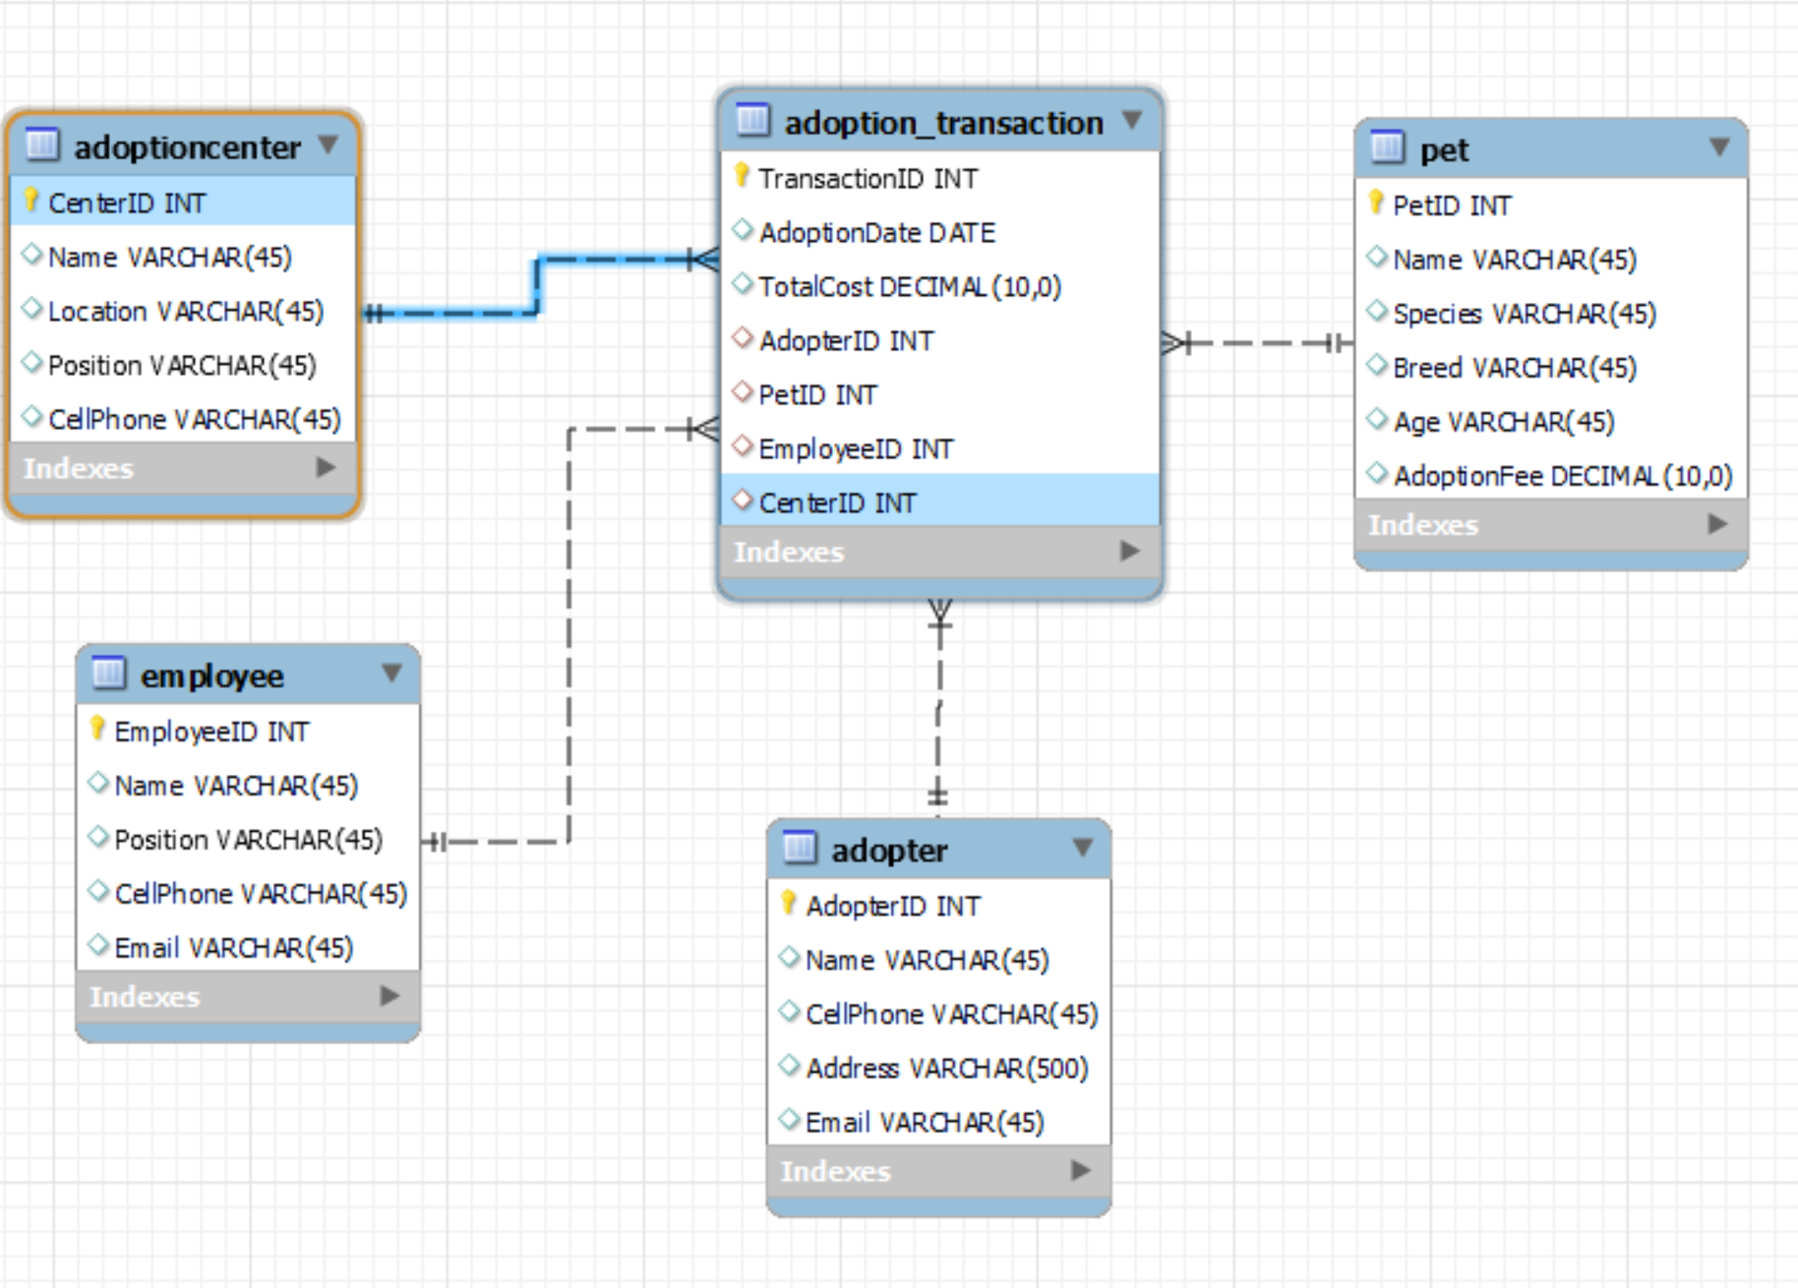

**After:**

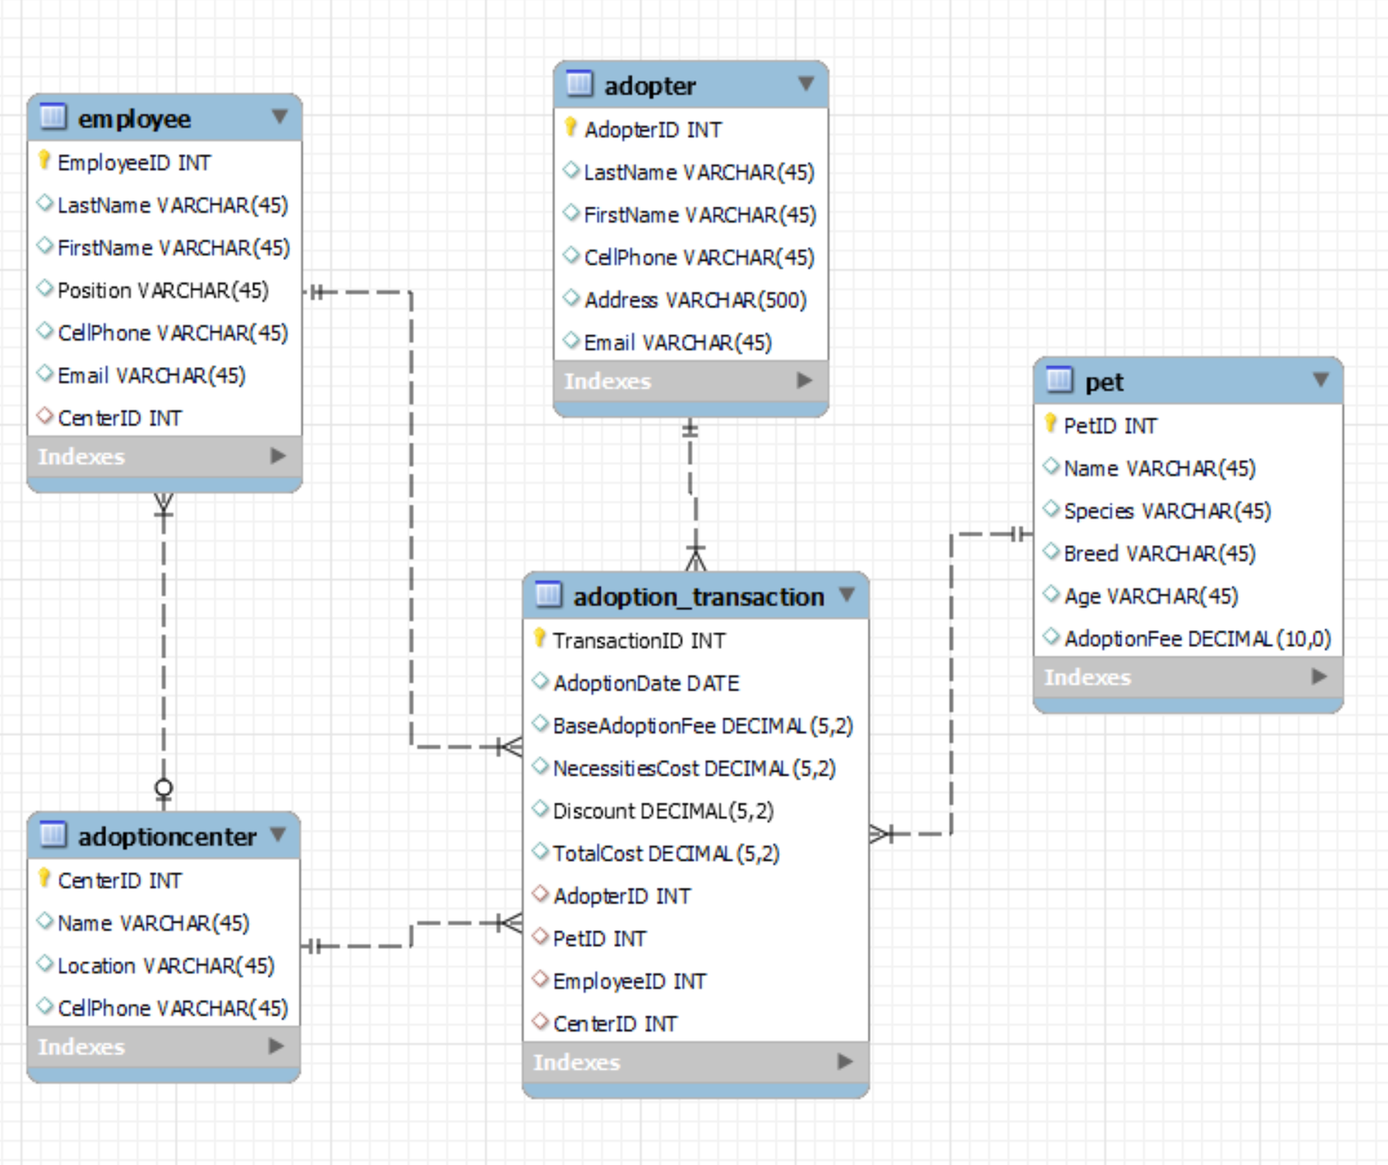

# Assumption and Limitations OF the design

**Assumptions:**

* This design assumes that a pet can go through multiple adoption transactions over time. This allows for returning the pet and the pet to be adopted again.
* This design assumes that the fees for the pets are fixed.
  + Though prices may vary depending on if the adopter has a discount or not.

**Limitations:**

* This design doesn’t include a changelog.
* No user authentication or authorization within this database.
* Fees aren’t influenced by other factors
* This design doesn’t include geographical factors for the Adoption centers.

# cardinality relationships

An Adopter can have multiple Transactions (One to Many)

A Pet can be apart of multiple Transactions (One to Many)

An Employee is able to file multiple Transactions (One to Many)

Multiple Transactions take place inside one AdoptionCenter (Many to One)

# Data Dictionary

| **Table** | **Field Name** | **Data Type** | **Nullable** | **Field Size** | **Ref** | **Description** |
| --- | --- | --- | --- | --- | --- | --- |
| Adopter | AdopterID | Int | not null | - | none | Adopter identifier number |
| Adopter | LastName | varchar | null | (45) | none | Adopters last name |
| Adopter | FirstName | varchar | null | (45) | none | adopters first name |
| Adopter | address | varchar | null | (150) | none | address of the adopter |
| Adopter | Phone# | varchar | null | (45) | none | phone number of adopter |
| Adopter | Email | varchar | null | (150) | none | email of adopter |
| Pet | PetID | Int | not null | - | none | identification number for the pet |
| Pet | Name | varchar | null | (45) | none | name of the pet |
| Pet | Species | varchar | null | (45) | none | species of the pet |
| Pet | Breed | varchar( | null | (45) | none | breed of pet |
| Pet | AdoptionFee | decimal | null | (5,2) | none | pet |
| Pet | age | int | null | - | none | age of pet |
| Employee | EmployeeID | int | not null | - | none | Identification number of Employee |
| Employee | LastName | varchar | null | (45) | none | Last name of employee |
| Employee | FirstName | varchar | null | (45) | none | First name of employee |
| Employee | Position | varchar | null | (45) | none | Position of employee |
| Employee | Email | varchar | null | (45) | none | email of employee |
| Employee | Phone# | varchar | null | (45) | none | Phone Number of Employee |
| Employee | CenterId | int | not null | - | Adoption Center | Adoption Center Identification Number |
| AdoptionCenter | CenterId | int | not null | - | none | Adoption Center identification number |
| AdoptionCenter | Name | varchar | null | (45) | none | Name of center |
| AdoptionCenter | Location | varchar | null | (45) | none | Location of center |
| AdoptionCenter | Contact # | varchar | null | (45) | none | Contact # of center |
| Adoption  Transaction | AdoptionDate | Date | null | - | none | date pet was adopted |
| Adoption  Transaction | Necessities Cost | decimal | null | (5,2) | none | cost of necessities to take care of pet |
| Adoption  Transaction | Discount | decimal | null | (5,2) | none | discounted amount of the total price to buy the pet |
| Adoption  Transaction | TotalCost | decimal | null | (5,2) | none | Total Cost of the animal |
| Adoption  Transaction | AdopterId | int | not null | - | Adopter | Adopter identification number |
| Adoption  Transaction | PetID | Int | not null | - | Pet | Pet identification number |
| Adoption  Transaction | EmployeeId | Int | not null | - | employee | Employee identification number |
| Adoption  Transaction | CenterID | Int | not null | - | AdoptionCenter | AdoptionCenter identification number |

# Sample Data

Adopter:

"(1001, 'Smith', 'Sam', '206-254-1234', '123 Main Street, Pleasantville, CA 98765', 'samsmith@gmail.com'), "

"(1002, 'Evanston', 'John', '206-254-2345', '456 Elm Avenue, Harmony City, TX 54321', 'johnevanston@gmail.com'), "

Pet:

“(01, 'Wrigley', 'Dog' , 'Golden Retriever','6 Months',275),"

"(02, 'Rizzo', 'Dog' , 'Dachshund ','5 Years',225),"

adoptionCenter:

"(1, 'Paws and Claws', 'New York', '123-456-7890'),"

"(2, 'Furry Friends', 'Los Angeles', '987-654-3210'),"

Employee:

"(26, 'Doe', 'John', 'Manager', '123-456-7890', 'john.doe@gmail.com', 1)," "(8, 'Smith', 'Jane', 'Caretaker', '987-654-3210', 'jane.smith@gmail.com', 11),"

adoption_Transaction:

"(11, '2023-04-15', 275.00, 100.00, 5.00, 370.00, 1001, 01, 45, 7), "

"(22, '2023-04-17', 50.00, 35.00, 0.00, 85.00, 1002, 06, 26, 1), "

# Java Code

## Table creation Code

import java.sql.Connection;

import java.sql.DriverManager;

import java.sql.Statement;

public class FinaltermProjectTableCreation {

public static void main(String[] args) {

// TODO Auto-generated method stub

Connection conn;

try {

// 1. Driver Loading and DB Connection!

conn = DriverManager.getConnection("jdbc:mysql://localhost:3306/pet_adoption", "root", "password");

System.out.println("Successfull DB Connection");

// 2. Write SQL queries to create a DB Table!

String adopterTable = "CREATE TABLE Adopter ("

+ "AdopterID INT AUTO_INCREMENT NOT NULL PRIMARY KEY,"

+ "LastName VARCHAR(45) NULL,"

+ "FirstName VARCHAR(45) NULL,"

+ "CellPhone VARCHAR(45) NULL,"

+ "Address VARCHAR(500) NULL,"

+ "Email VARCHAR(45) NULL"

+ ")";

String petTable = "CREATE TABLE Pet ("

+ "PetID INT AUTO_INCREMENT NOT NULL PRIMARY KEY,"

+ "Name VARCHAR(45) NULL,"

+ "Species VARCHAR(45) NULL,"

+ "Breed VARCHAR(45) NULL,"

+ "Age VARCHAR(45) NULL,"

+ "AdoptionFee DECIMAL NULL"

+ ")";

String adoptionCenterTable = "CREATE TABLE AdoptionCenter ("

+ "CenterID INT AUTO_INCREMENT NOT NULL PRIMARY KEY,"

+ "Name VARCHAR(45) NULL,"

+ "Location VARCHAR(45) NULL,"

+ "CellPhone VARCHAR(45) NULL"

+ ")";

String employeeTable = "CREATE TABLE Employee ("

+ "EmployeeID INT AUTO_INCREMENT NOT NULL PRIMARY KEY,"

+ "LastName VARCHAR(45) NULL,"

+ "FirstName VARCHAR(45) NULL,"

+ "Position VARCHAR(45) NULL,"

+ "CellPhone VARCHAR(45) NULL,"

+ "Email VARCHAR(45) NULL,"

+ "CenterID INT,"

+ "FOREIGN KEY (CenterID) REFERENCES AdoptionCenter(CenterID)"

+ ")";

String adoptionTransactionTable = "CREATE TABLE adoption_transaction ("

+ "TransactionID INT AUTO_INCREMENT NOT NULL PRIMARY KEY,"

+ "AdoptionDate DATE NULL,"

+ "BaseAdoptionFee DECIMAL(5,2) NULL,"

+ "NecessitiesCost DECIMAL(5,2) NULL,"

+ "Discount DECIMAL(5,2) NULL,"

+ "TotalCost DECIMAL(5,2) NULL,"

+ "AdopterID INT,"

+ "PetID INT,"

+ "EmployeeID INT,"

+ "CenterID INT,"

+ "FOREIGN KEY (PetID) REFERENCES Pet(PetID),"

+ "FOREIGN KEY (AdopterID) REFERENCES Adopter(AdopterID),"

+ "FOREIGN KEY (EmployeeID) REFERENCES Employee(EmployeeID),"

+ "FOREIGN KEY (CenterID) REFERENCES AdoptionCenter(CenterID)"

+ ")";

// 3. Create the statement object to execute SQL queries.

Statement smt = conn.createStatement();

//4. Execute SQL Query using the execute method of the statement object

boolean result1 = smt.execute(adopterTable);

boolean result2 = smt.execute(petTable);

boolean result3 = smt.execute(adoptionCenterTable);

boolean result4 = smt.execute(employeeTable);

boolean result5 = smt.execute(adoptionTransactionTable);

System.out.println("Result: " + result1);

System.out.println("Result: " + result2);

System.out.println("Result: " + result3);

System.out.println("Result: " + result4);

System.out.println("Result: " + result5);

// 5. Close

if (smt != null)

smt.close();

if (conn != null)

conn.close();

}

catch(Exception e){

System.out.println("Error: "+e);

}

}

}

## Data Insertion Code

import java.sql.Connection;

import java.sql.DriverManager;

import java.sql.Statement;

public class FinalDataInsertion {

public static void main(String[] args) {

// TODO Auto-generated method stub

Connection conn;

try {

// 1. Driver Loading and DB Connection!

conn = DriverManager.getConnection("jdbc:mysql://localhost:3306/pet_adoption", "root", "password");

System.out.println("DB Connection Success!");

// 2. Write SQL queries to create a DB Table!

String sql1 = "INSERT INTO adopter VALUES "

+ "(1001, 'Smith', 'Sam', '206-254-1234', '123 Main Street, Pleasantville, CA 98765', 'samsmith@gmail.com'), "

+ "(1002, 'Evanston', 'John', '206-254-2345', '456 Elm Avenue, Harmony City, TX 54321', 'johnevanston@gmail.com'), "

+ "(1003, 'Murray', 'Dale', '206-254-3456', '789 Oak Lane, Serenity Springs, NY 12345', 'dalemurray@gmail.com'), "

+ "(1004, 'Murphy', 'Jerry', '206-545-8765', '101 Maple Court, Tranquil Meadows, FL 67890', 'jerrymurphy@gmail.com'), "

+ "(1005, 'Allanach', 'Jerry', '206-254-4567', '234 Pine Road, Blissful Heights, AZ 45678', 'jerryallanach@gmail.com'),"

+ "(1006, 'Pitt', 'Brad', '206-546-1234', '567 Cedar Street, Dreamland Falls, IL 23456', 'bradpitt@gmail.com'),"

+ "(1007, 'Fontaine', 'Joan', '206-546-2345', '890 Birch Lane, Whispering Pines, OH 78901', 'johnfontaine@gmail.com'),"

+ "(1008, 'Prefontaine', 'Steve', '206-546-3456', '112 Willow Avenue, Rainbow Valley, WA 34567', 'steveprefontaine@gmail.com'),"

+ "(1009, 'Jacobs', 'Noah', '206-546-4567', '345 Redwood Drive, Jubilation Junction, GA 89012', 'noahjacobs@gmail.com'),"

+ "(1010, 'Kap', 'Colin', '206-546-5678', '678 Juniper Lane, Radiant Ridge, MI 12345', 'colinkap@gmail.com'),"

+ "(1011, 'Ferrari', 'Enzo', '206-546-6789', '901 Spruce Street, Enchanted Gardens, PA 67890', 'enzoferrari@gmail.com'),"

+ "(1012, 'Neutron', 'Jimmy', '206-546-7890', '234 Laurel Road, Mystic Hills, NC 23456', 'jimmyneutron@gmail.com')";

String sql2 = "INSERT INTO pet "

+ "VALUES(01, 'Wrigley', 'Dog' , 'Golden Retriever','6 Months',275),"

+ "(02, 'Rizzo', 'Dog' , 'Dachshund ','5 Years',225),"

+ "(03, 'Payton', 'Dog' , 'Bernedoodle','7 Years',150),"

+ "(04, 'Madison', 'Cat' , 'Siamese','5 Months',100),"

+ "(05, 'Harry', 'Cat' , 'Persian','3 Year',100),"

+ "(06, 'Sosa', 'Cat' , 'American Shorthair','8 Years',50),"

+ "(07, 'Jordan', 'Bird' , 'Grey Parrot','6 Months',35),"

+ "(08, 'Pippen', 'Bird' , 'Canary','1 Year',15),"

+ "(09, 'Rose', 'Bird' , 'Cockatoo','2 Years',15),"

+ "(10, 'Hester', 'Rabbit' , 'Holland Lop','9 Months',20),"

+ "(11, 'Kane', 'Chinchilla' , 'White Mosaic','1 Year',50),"

+ "(12, 'Ernie', 'Hamster' , 'Winter White Russian Dwarf ','3 Months',5)";

String sql3 = "INSERT INTO AdoptionCenter " +

"VALUES " +

"(1, 'Paws and Claws', 'New York', '123-456-7890')," +

"(2, 'Furry Friends', 'Los Angeles', '987-654-3210')," +

"(3, 'Happy Tails', 'Chicago', '555-555-5555')," +

"(4, 'Pets Haven', 'Houston', '777-777-7777')," +

"(5, 'Animal Allies', 'San Francisco', '333-333-3333')," +

"(6, 'Pet Paradise', 'Miami', '444-444-4444')," +

"(7, 'Companion Care', 'Denver', '666-666-6666')," +

"(8, 'Rescue Ranch', 'Seattle', '222-222-2222')," +

"(9, 'Forever Furry', 'Boston', '888-888-8888')," +

"(10, 'Pawsitive Vibes', 'Dallas', '999-999-9999')," +

"(11, 'Cuddles and Co.', 'Austin', '111-111-1111')," +

"(12, 'Whiskers and Wags', 'Portland', '222-222-2222')," +

"(13, 'Furry Haven', 'Phoenix', '333-333-3333')," +

"(14, 'Pet Harmony', 'Las Vegas', '444-444-4444')," +

"(15, 'Tails of Joy', 'Atlanta', '555-555-5555')";

String sql4 = "INSERT INTO Employee " +

"VALUES " +

"(26, 'Doe', 'John', 'Manager', '123-456-7890', 'john.doe@gmail.com', 1)," +

"(8, 'Smith', 'Jane', 'Caretaker', '987-654-3210', 'jane.smith@gmail.com', 11)," +

"(45, 'Johnson', 'Michael', 'Assistant', '555-555-5555', 'michael.johnson@gmail.com', 7)," +

"(19, 'Williams', 'Emily', 'Trainer', '777-777-7777', 'emily.williams@gmail.com', 5)," +

"(37, 'Brown', 'David', 'Coordinator', '333-333-3333', 'david.brown@gmail.com', 12)," +

"(12, 'Lee', 'Sarah', 'Veterinarian', '444-444-4444', 'sarah.lee@gmail.com', 15)," +

"(3, 'Garcia', 'Robert', 'Volunteer', '666-666-6666', 'robert.garcia@gmail.com', 2)," +

"(31, 'Martinez', 'Olivia', 'Caretaker', '222-222-2222', 'olivia.martinez@gmail.com', 14)," +

"(22, 'Wilson', 'William', 'Assistant', '888-888-8888', 'william.wilson@gmail.com', 8)," +

"(49, 'Anderson', 'Ava', 'Trainer', '999-999-9999', 'ava.anderson@gmail.com', 9)," +

"(6, 'Lopez', 'Ethan', 'Coordinator', '777-888-9999', 'ethan.lopez@gmail.com', 10)," +

"(42, 'Thomas', 'Sophia', 'Veterinarian', '111-222-3333', 'sophia.thomas@gmail.com', 6)," +

"(15, 'Hall', 'Daniel', 'Volunteer', '444-555-6666', 'daniel.hall@gmail.com', 3)," +

"(29, 'Clark', 'Grace', 'Caretaker', '777-999-1111', 'grace.clark@gmail.com', 4)," +

"(5, 'Rodriguez', 'Liam', 'Assistant', '888-777-5555', 'liam.rodriguez@gmail.com', 13)";

String sql5 = "INSERT INTO adoption_transaction "

+ "VALUES "

+ "(11, '2023-04-15', 275.00, 100.00, 5.00, 370.00, 1001, 01, 45, 7), "

+ "(22, '2023-04-17', 50.00, 35.00, 0.00, 85.00, 1002, 06, 26, 1), "

+ "(33, '2023-04-17', 100.00, 40.00, 8.00, 132.00, 1003, 04, 5, 13), "

+ "(44, '2023-04-17', 150.00, 25.00, 10.00, 165.00, 1004, 03, 37, 12), "

+ "(55, '2023-04-23', 50.00, 75.00, 0.00, 125.00, 1005, 11, 26, 1), "

+ "(66, '2023-04-30', 225.00, 30.00, 0.00, 255.00, 1006, 02, 49, 9), "

+ "(77, '2023-05-01', 20.00, 25.00, 0.00, 45.00, 1007, 10, 42, 6),"

+ "(88, '2023-05-01', 15.00, 60.00, 0.00, 75.00, 1008, 08, 26, 1),"

+ "(99, '2023-05-04', 5.00, 10.00, 7.00, 8.00, 1009, 12, 31, 8),"

+ "(110, '2023-05-15', 35.00, 20.00, 15.00, 40.00, 1010, 07, 15, 3),"

+ "(111, '2023-05-25', 100.00, 155.00, 0.00, 255.00, 1011, 05, 29, 4),"

+ "(112, '2023-06-07', 15.00, 20.00, 25.00, 10.00, 1012, 09, 19, 5)";

// create the statement object to execute sql queries

Statement smt = conn.createStatement();

// Execute SQL query using the execute method of the statement object

boolean result1 = smt.execute(sql1) ;

boolean result2 = smt.execute(sql2) ;

boolean result3 = smt.execute(sql3) ;

boolean result4 = smt.execute(sql4) ;

boolean result5 = smt.execute(sql5) ;

System.out.print("Result: " + result1);

System.out.print("Result: " + result2);

System.out.print("Result: " + result3);

System.out.print("Result: " + result4);

System.out.print("Result: " + result5);

// 3. Create the statement object to execute SQL queries.

//4. Execute SQL Query using the execute method of the statement object

System.out.println("Result: " + result1);

// 5. Close

if (smt != null)

smt.close();

if (conn != null)

conn.close();

}

catch(Exception e){

System.out.println("Error: "+e);

}

}

}

## Screenshot of DB tables and data instance

# 

# 

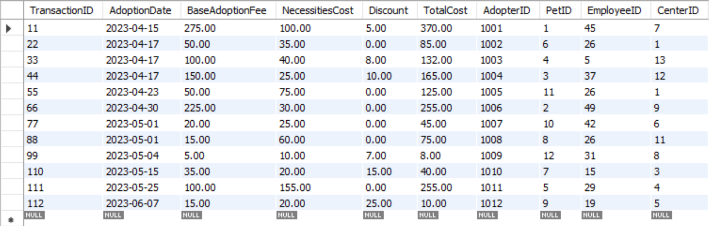

# 

# 

# 

# 

# 

# 

# 

# 

# 

# 

# 

# Own SQL queries in Java

*[Please come up with 3 own queries and include them with the screenshot of the outputs.]*

**Logan’s Queries:**

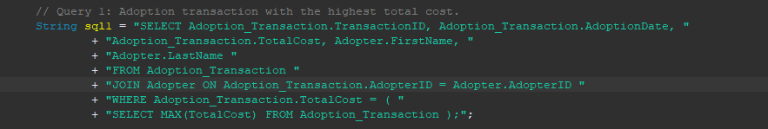

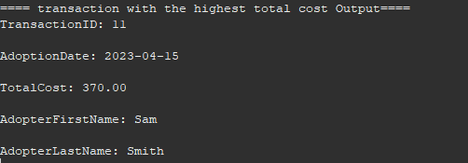

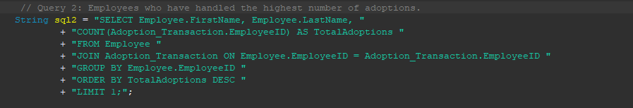

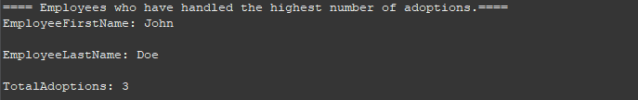

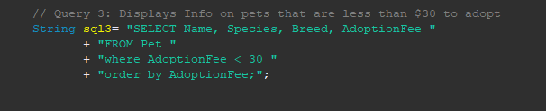

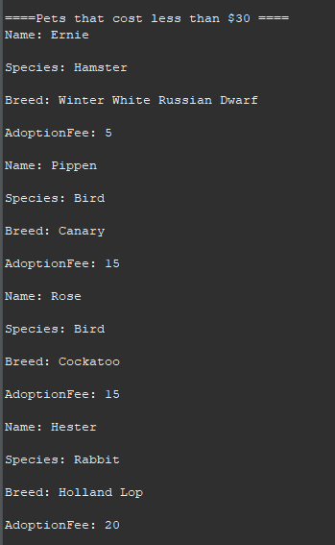

**Celine’s Queries:**

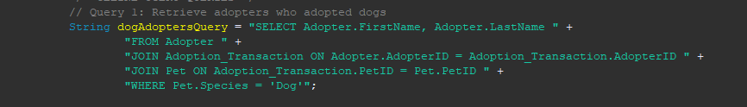

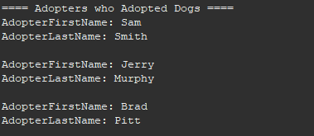



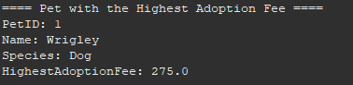

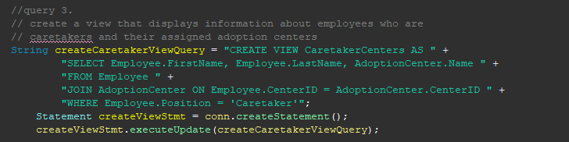

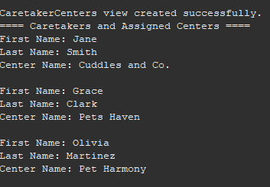

**Jacob Queries:**

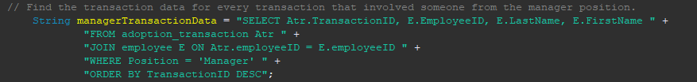

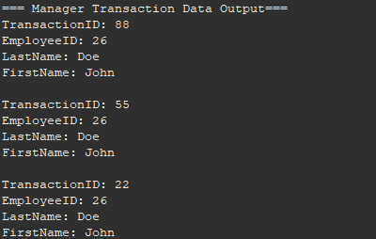

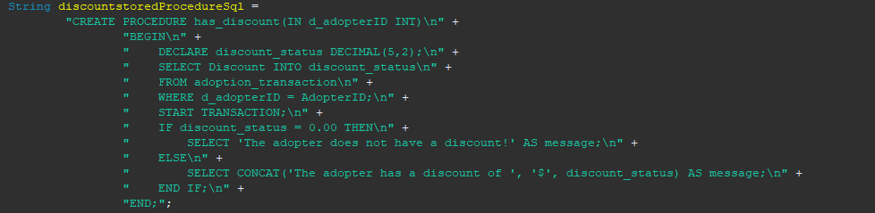

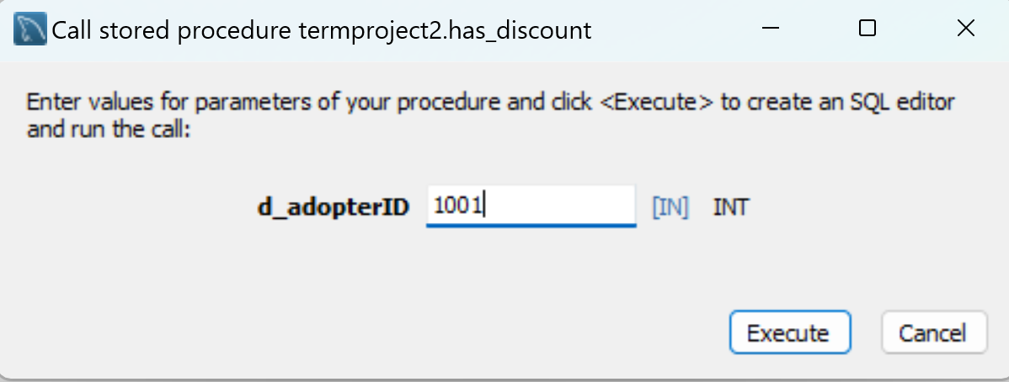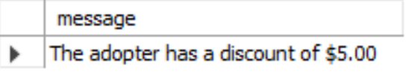

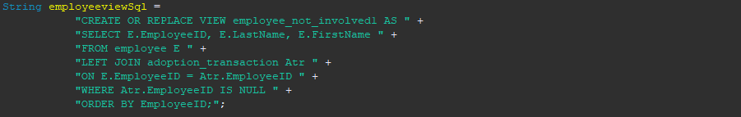

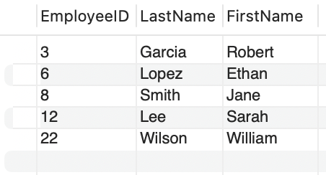

**Ishaan Queries:**

**

